HUMAN EYE

SCENE 1 — THE MYSTERY BEGINS

Environment
A realistic park at night. The four friends are sitting on a bench, looking up at the night sky.
The Moon is clearly visible, surrounded by scattered stars.
Kabir:
“Look at the Moon.”
Ishaan:
“It’s hard to believe it’s that far away.”
Manav:
“Imagine actually standing there.”
Meera:
“And then looking back at Earth.”
Kabir keeps looking up.
Kabir:
“I wonder what people would eat up there.”
Ishaan:
“You’re already thinking about food?”
Kabir:
“I was just wondering.”
They smile and continue looking at the sky.
Kabir:
“And the stars…”
Ishaan:
“Some of them are incredibly far away.”
Manav keeps looking upward.
Manav:
“Wait…”
Kabir:
“What?”
Manav:
“If they’re that far away… how can we see them?”
The four friends continue looking up at the sky.
Ishaan:
“Actually… that’s strange.”
Kabir:
“Yeah. They’re so tiny from here.”
Manav:
“And yet we can still see them.”
Meera looks up at the stars.
Meera:
“It’s actually because light from an object reaches our eyes, and our eyes detect that light.”
Kabir:
“So that’s how we can see things from so far away?”
Meera:
“Exactly.”
Manav looks at the Moon again.
Manav:
“But how does it all work?”
Ishaan looks toward Meera.
Ishaan:
“Now I’m curious about that too.”
Meera opens her magical book.
The pages begin to glow.
A portal opens.
The four friends step through.

TRANSITION
The scene fades into a new learning environment.

SCENE 2 — MEET NIKO

Environment
The learner is now standing in an Observatory of Vision. A giant beam of starlight passes through the environment. At the centre stands a realistic human figure. Around the environment are subtle optical phenomena: reflections, beams, apertures, lenses. Then the AI appears.

NIKO - THE VISION INVESTIGATOR OFFICER
His main capability is that he can visualise things humans normally cannot see. That becomes his superpower.
He can:
- SCAN — identify structures.
- INSIDE- Move inside the eye.
- SIMULATE — change brightness, distance, lens curvature etc.
- TRACE — follow light or electrical signals.
- FREEZE — stop biological processes mid-action.
- REPLAY — replay what just happened slowly.
Learner can ask Niko questions naturally. Niko asks questions to users and changes questions based on what the learner understands.

NIKO — INTRODUCTION
Niko:
“Hey! I’m Niko. Your Vision Investigator Officer.”
"So you want to know how light becomes sight?"
"Then watching from out here won't help."
The human figure appears.

NIKO
"We need to go inside somewhere humans can't."
He raises his hand.
Prompt and VO: Click on the SCAN button.

SCAN MODE
A blue scanning wave passes through the human.
Skin becomes translucent.
Muscles.
Skull.
Brain.
Both eyes remain visible.

NIKO
"There."
One eye illuminates.

NIKO
"Your first destination."
The learner sees the eye inside the actual skull, so they understand its anatomical position.
Then Niko makes a pinching gesture.
The entire human freezes and disappears.
The selected eye begins enlarging.
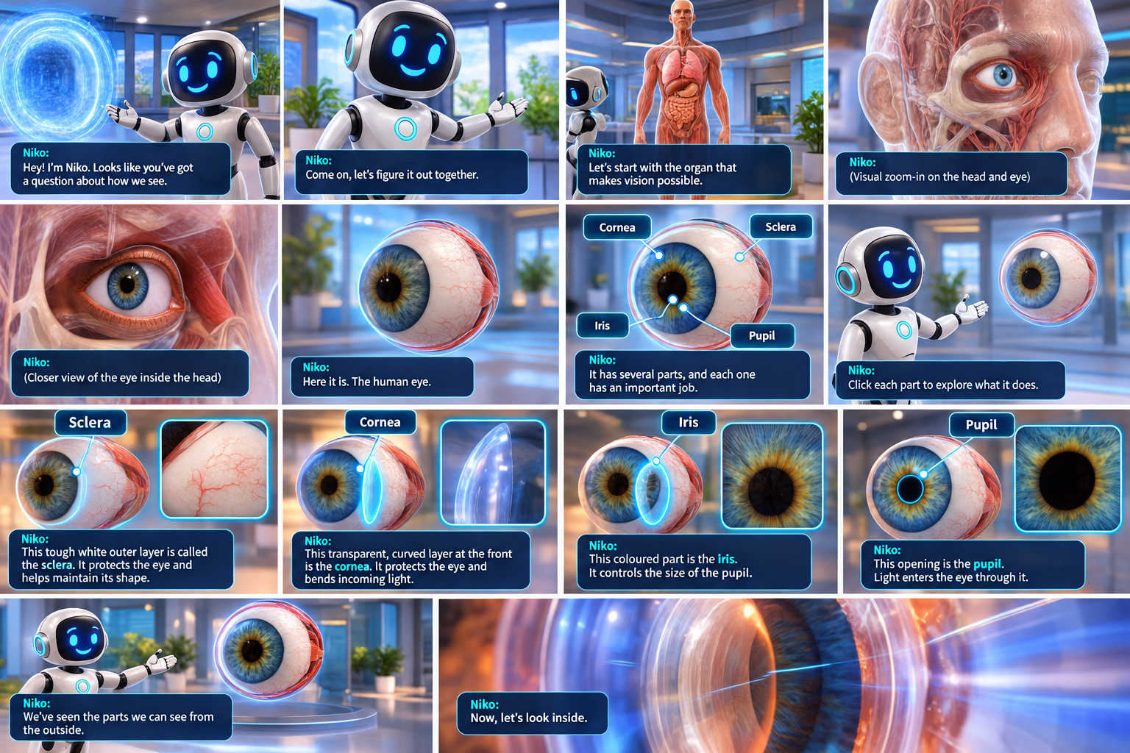
The eye is now in front of the user and it slowly rotates.
Niko:
“Here it is. The human eye.”
Niko gestures toward the eye.
Niko:
“It has several parts, and each one has an important job.”
Niko snaps its finger and the major visible parts become subtly highlighted one after another.
Niko:
“Click or ask Niko about each part to explore what it does.”

LEARNER INTERACTION
The learner clicks a highlighted part.
The camera moves closer to the selected structure while Niko explains it.
After each explanation, the view returns to the complete eye before the learner selects the next part.

SCLERA
The learner clicks the white outer layer.
The camera moves closer to the white outer surface.
The sclera becomes highlighted. Rest parts become transparent or translucent.
Niko:
“This tough white outer layer is called the sclera. It protects the eye and helps maintain its shape.”
The view returns to the complete eye.

CORNEA
The learner clicks the transparent curved front surface.
The camera moves toward the front of the eye.
The cornea becomes highlighted. Rest parts become transparent or translucent.
Niko:
“This transparent, curved layer at the front is the cornea. It protects the eye and bends incoming light.”
The view returns to the complete eye.

IRIS
The learner clicks the coloured ring.
The camera moves closer to the front of the eye.
The iris becomes highlighted. Rest parts become transparent or translucent.
Niko:
“This coloured part is the iris. It controls the size of the pupil.”

PUPIL
The learner clicks the opening at the centre of the iris.
The pupil becomes highlighted. Rest parts become transparent or translucent.
Niko:
“This opening is the pupil. Light enters the eye through it.”
The camera pulls back to show the complete eye.

TRANSITION
Niko:
“We’ve seen the parts we can see from the outside. Now, let’s look inside.”
Prompt and VO: “Click on the Inside View button to see how the eye looks from the inside.”

SCENE 3 — INSIDE THE EYE
The cornea becomes transparent and we can look into the interior of the eye. The internal structures become visible.
Niko snaps its finger and the major visible parts become subtly highlighted one after another.
Niko:
“Click or ask Niko about each part to explore what it does.”

LEARNER INTERACTION
The learner clicks a highlighted part.
The camera moves closer to the selected structure while Niko explains it.
After each explanation, the view returns to the complete eye before the learner selects the next part.
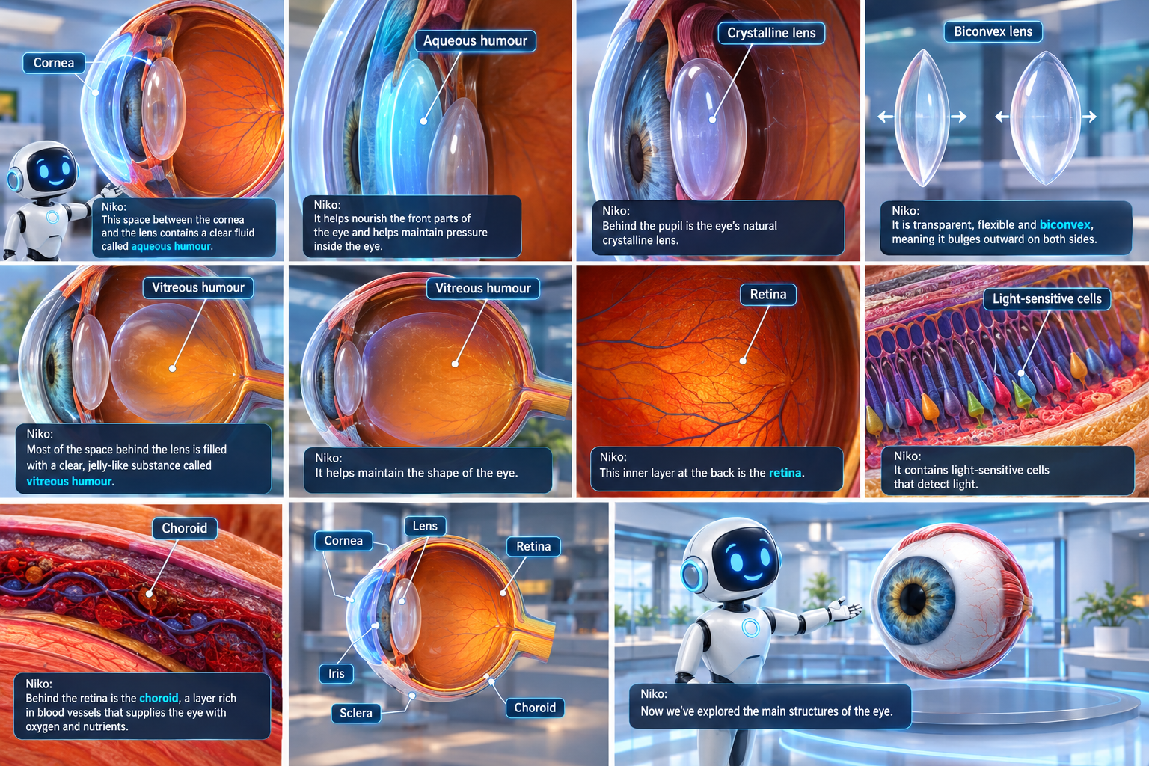

AQUEOUS HUMOUR
The space between the cornea and lens becomes highlighted.
The camera moves closer to this fluid-filled region.
Niko:
“This space between the cornea and the lens contains a clear fluid called aqueous humour.”
Niko:
“It helps nourish the front parts of the eye and helps maintain pressure inside the eye.”

CRYSTALLINE LENS
The natural lens becomes highlighted.
The camera moves closer to the lens.
Niko:
“Behind the pupil is the eye’s natural crystalline lens.”
The lens is shown clearly in close-up.
Niko:
“It is transparent, flexible and biconvex, meaning it bulges outward on both sides.”
The lens changes shape slightly.
Niko:
“It can change its shape to help focus light from objects at different distances.”
The view widens again to show the lens in its position inside the eye.

VITREOUS HUMOUR
The large cavity behind the lens becomes highlighted.
The camera moves through this region toward the back of the eye.
Niko:
“Most of the space behind the lens is filled with a clear, jelly-like substance called vitreous humour.”
Niko:
“It helps maintain the shape of the eye.”

RETINA
The inner back surface of the eye becomes highlighted.
The camera moves very close to the retinal surface.
Niko:
“This inner layer at the back is the retina.”
The retinal surface becomes detailed.
Niko:
“It contains light-sensitive cells that detect light.”
The camera moves slightly deeper to reveal the layer behind the retina.

CHOROID
The layer behind the retina becomes highlighted.
Niko:
“Behind the retina is the choroid, a layer rich in blood vessels that supplies the eye with oxygen and nutrients.”
The camera gradually pulls back until the complete eye is visible again.
Niko:
“Now we’ve explored the main structures of the eye.”

SCENE 4 — HOW IS THE EYE CONNECTED TO THE BRAIN?
The complete eye remains visible.
The camera slowly moves toward the back of the eye.
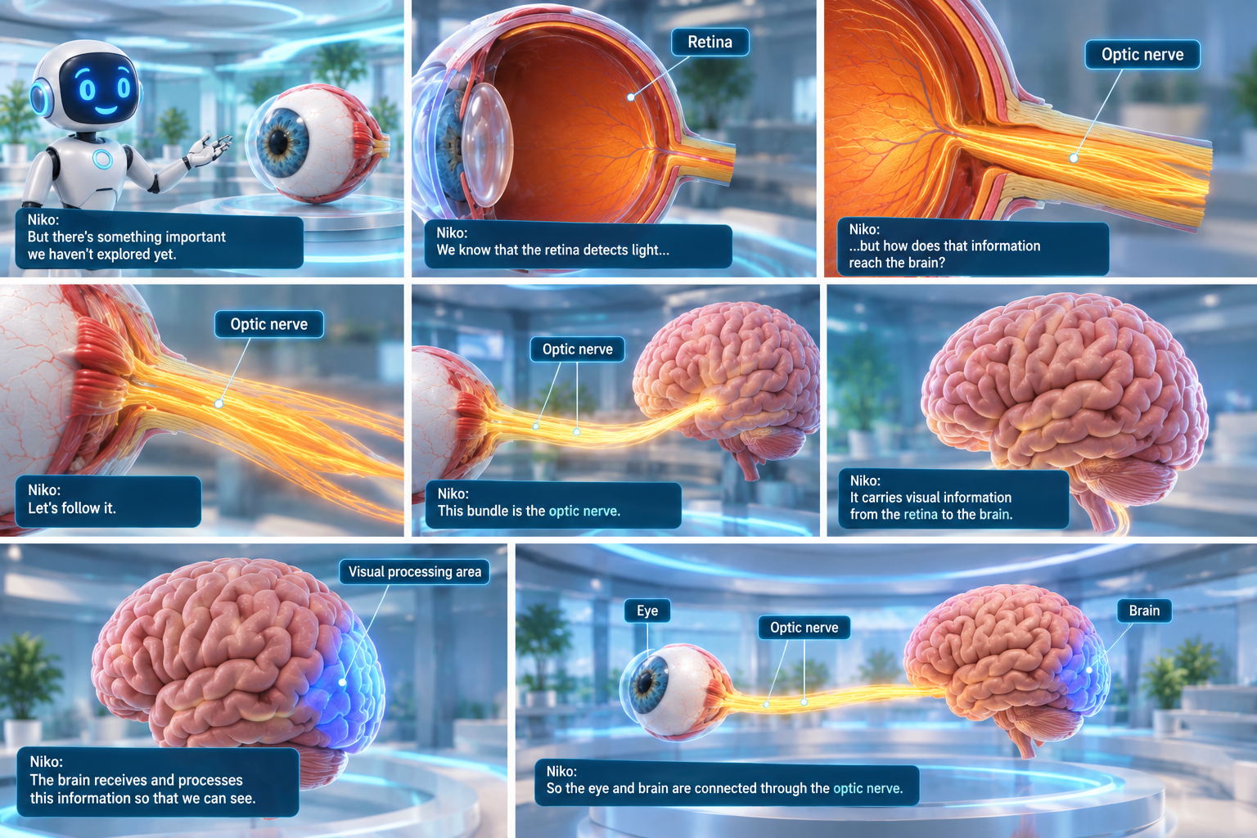
Niko:
“But there’s something important we haven’t explored yet.”
The back of the eye comes closer.
Niko:
“We know that the retina detects light…”
A bundle extending from the back of the eye becomes visible.
Niko:
“…but how does that information reach the brain?”
The bundle becomes highlighted.
Niko:
“Let’s follow it.”

OPTIC NERVE
The camera moves close to the bundle leaving the back of the eye.
The optic nerve becomes highlighted.
Niko:
“This bundle is the optic nerve.”
The camera follows the optic nerve away from the eye toward a realistic brain model.
Niko:
“It carries visual information from the retina to the brain.”
The brain becomes visible.
The visual processing area at the back of the brain is highlighted.
Niko:
“The brain receives and processes this information so that we can see.”
The view widens to show the eye, optic nerve and brain together.
Niko:
“So the eye and brain are connected through the optic nerve.”

PART 3 — HOW THE HUMAN EYE WORKS

SCENE 5 — LIGHT ENTERS THE EYE
A clear object appears in front of the learner.
A beam of light travels from the object toward the eye.
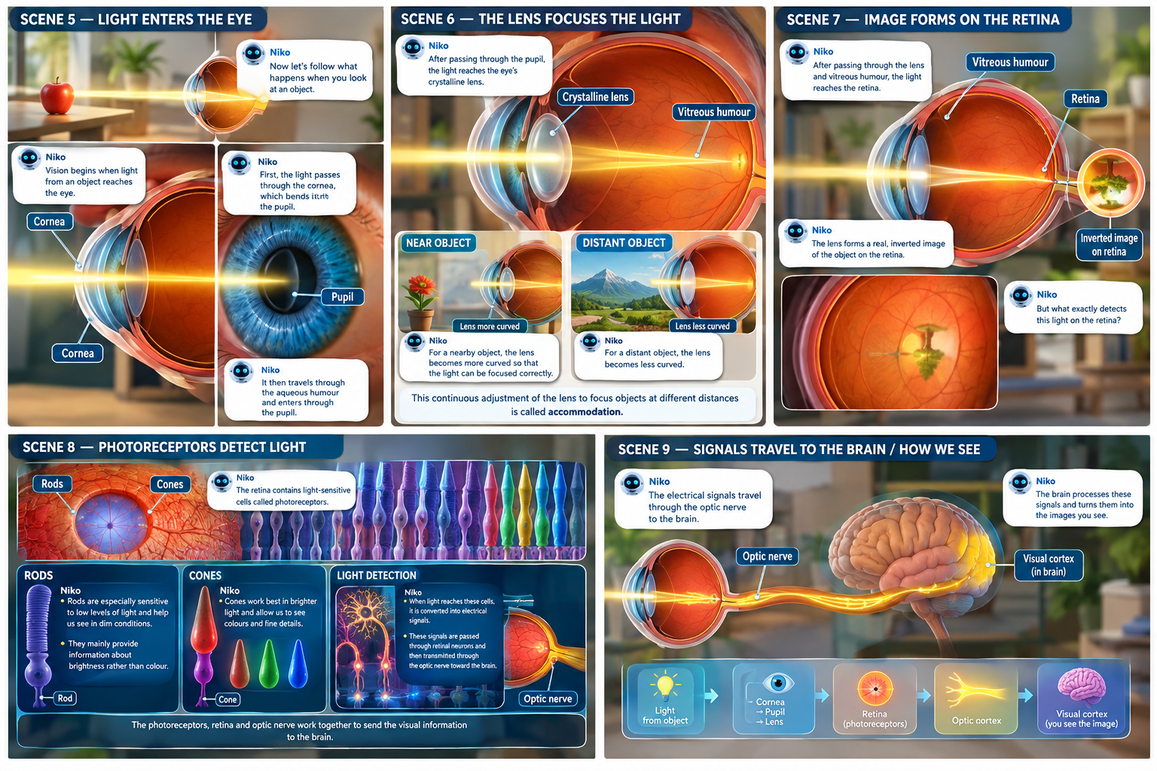
Niko:
“We've been looking at the eye. Now let’s follow what happens when you look at an object.”
The camera follows the light toward the eye.
Niko:
“Vision begins when light from an object reaches the eye.”
The light reaches the cornea.
Niko:
“First, the light passes through the cornea, which bends it.”
The camera moves closer to the front of the eye as the light continues through the aqueous humour.
Niko:
“It then travels through the aqueous humour and enters through the pupil.”

PUPIL RESPONSE

Learner Interaction
Prompt + VO:
“Change the brightness and observe what happens to the pupil.”
The learner increases the brightness through a slider.
The pupil gradually becomes smaller.
Niko:
“In bright light, the pupil becomes smaller.”
The learner decreases the brightness.
The pupil becomes larger.
Niko:
“In dimmer light, the pupil becomes larger.”
Niko:
“The iris controls the size of the pupil and therefore regulates how much light enters the eye.”

SCENE 6 — THE LENS FOCUSES THE LIGHT
The light continues through the pupil toward the crystalline lens.
The camera follows the light and moves closer to the lens.
The lens becomes clearly visible.
Niko:
“After passing through the pupil, the light reaches the eye’s crystalline lens.”
The light rays bend as they pass through the lens.

NEAR OBJECT
A nearby object appears.
The lens becomes more curved.
Niko:
“For a nearby object, the lens becomes more curved so that the light can be focused correctly.”

DISTANT OBJECT
The nearby object disappears. A distant object appears. The lens becomes less curved.
Niko:
“For a distant object, the lens becomes less curved.”
Niko:
“This continuous adjustment of the lens to focus objects at different distances is called accommodation.”
The camera pulls back enough to show the light continuing through the vitreous humour toward the retina.

SCENE 7 — IMAGE FORMS ON THE RETINA
The camera follows the light through the vitreous humour toward the back of the eye. The retina comes into view. The light rays converge on the retinal surface.
A clear real, inverted image of the object appears on the retina.
Niko:
“After passing through the lens and vitreous humour, the light reaches the retina.”
The retinal image is shown clearly.
Niko:
“The lens forms a real, inverted image of the object on the retina.”
The camera moves closer to the retinal surface.
Niko:
“But what exactly detects this light on the retina?”

SCENE 8 — PHOTORECEPTORS DETECT LIGHT
The camera continues deeper into the retina. The retinal layer enlarges until individual light-sensitive cells can be seen. Two types of photoreceptors become visible.
Niko:
“The retina contains light-sensitive cells called photoreceptors.”

RODS
Rod-shaped cells become highlighted.
Niko:
“Rods are especially sensitive to low levels of light and help us see in dim conditions.”
Niko:
“They mainly provide information about brightness rather than colour.”

CONES
Cone-shaped cells become highlighted.
Niko:
“Cones work best in brighter light and allow us to see colours and fine details.”

LIGHT DETECTION
Light reaches the photoreceptors. The cells respond.
Niko:
“When light reaches these cells, it is converted into electrical signals.”
The signals move through the retinal cells toward the optic nerve.
Niko:
“These signals are passed through the retina toward the optic nerve.”
The camera gradually moves back to show the relationship between the photoreceptors, retina and optic nerve.

SCENE 9 — SIGNALS TRAVEL TO THE BRAIN
The camera follows the signals leaving the retina. The signals travel through the optic nerve.
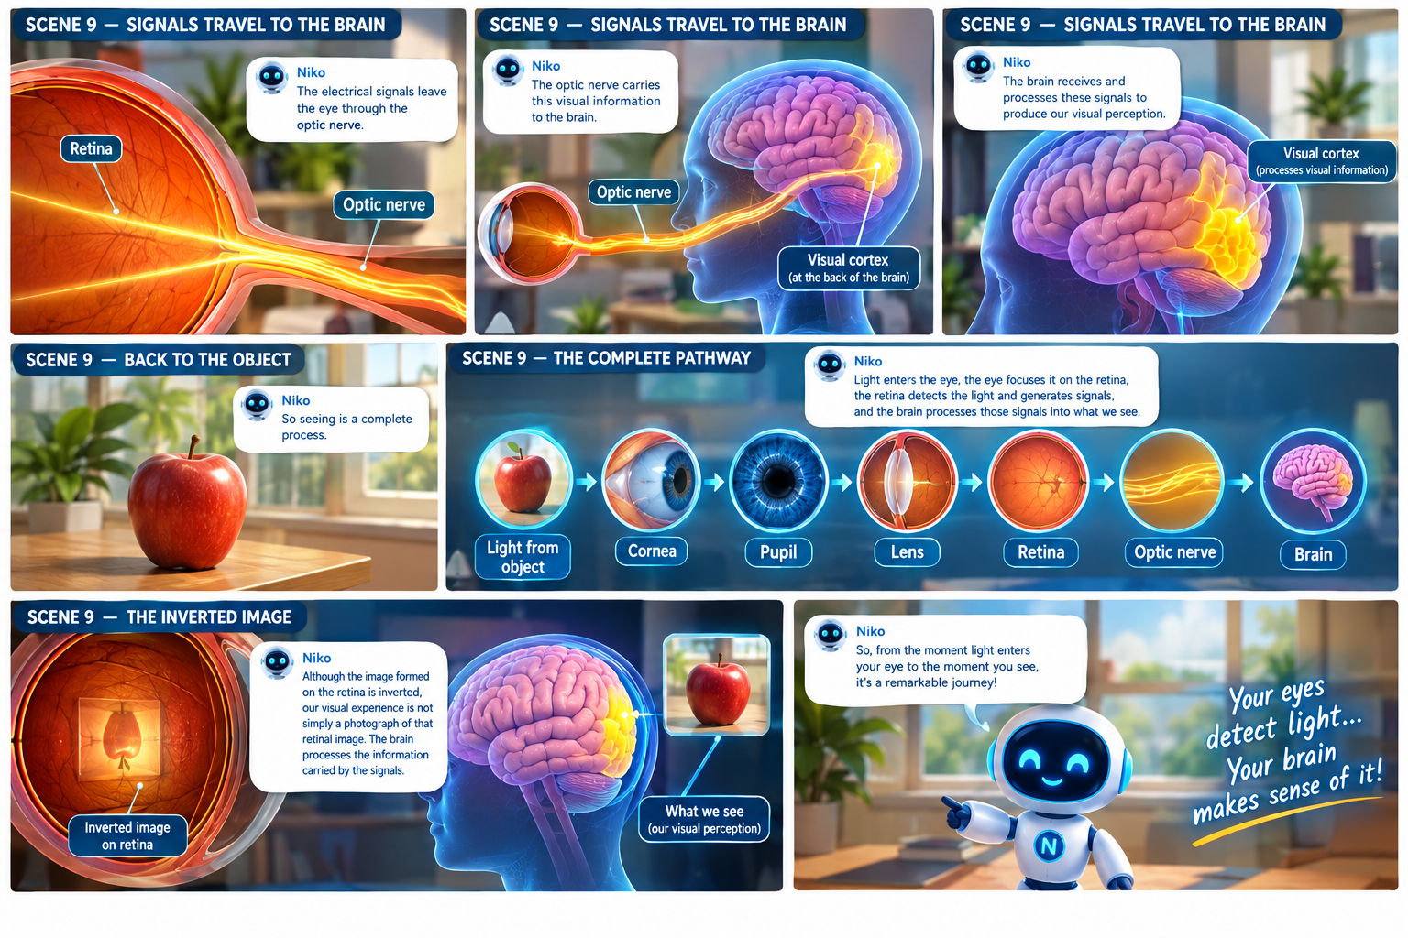
Niko:
“The electrical signals leave the eye through the optic nerve.”
The camera follows the optic nerve toward the brain.
Niko:
“The optic nerve carries this visual information to the brain.”
The signals enter the brain.
The visual processing area at the back of the brain becomes highlighted.
Niko:
“The brain receives and processes these signals to produce our visual perception.”
The original object appears clearly again.
Niko:
“Although the image formed on the retina is inverted, our visual experience is not simply a photograph of that retinal image. The brain processes the information carried by the signals.”

SCENE 10 — THE COMPLETE WORKING
The camera moves back to show the complete eye.
Niko:
“So seeing is a complete process.”
“Now you’ve followed the journey from the moment light enters the eye to the moment the brain processes the information.”

SCENE 11 — FINAL CURIOSITY
Niko:
“Your eyes are constantly responding to the world around you—even when you’re not thinking about it.”
“So here’s something to think about…what happens when the eye cannot focus light properly?”
The scene briefly shows a distant object becoming slightly blurred, while a nearby object remains clear.
Niko:
“Why might some things look blurry, even when your eyes are working?”
The blurred object slowly fades.

FINAL TRANSITION
The eye slowly fades into the dark learning environment.
CUT TO BLACK.

